Goderich Art Club
SHOW AND SALE
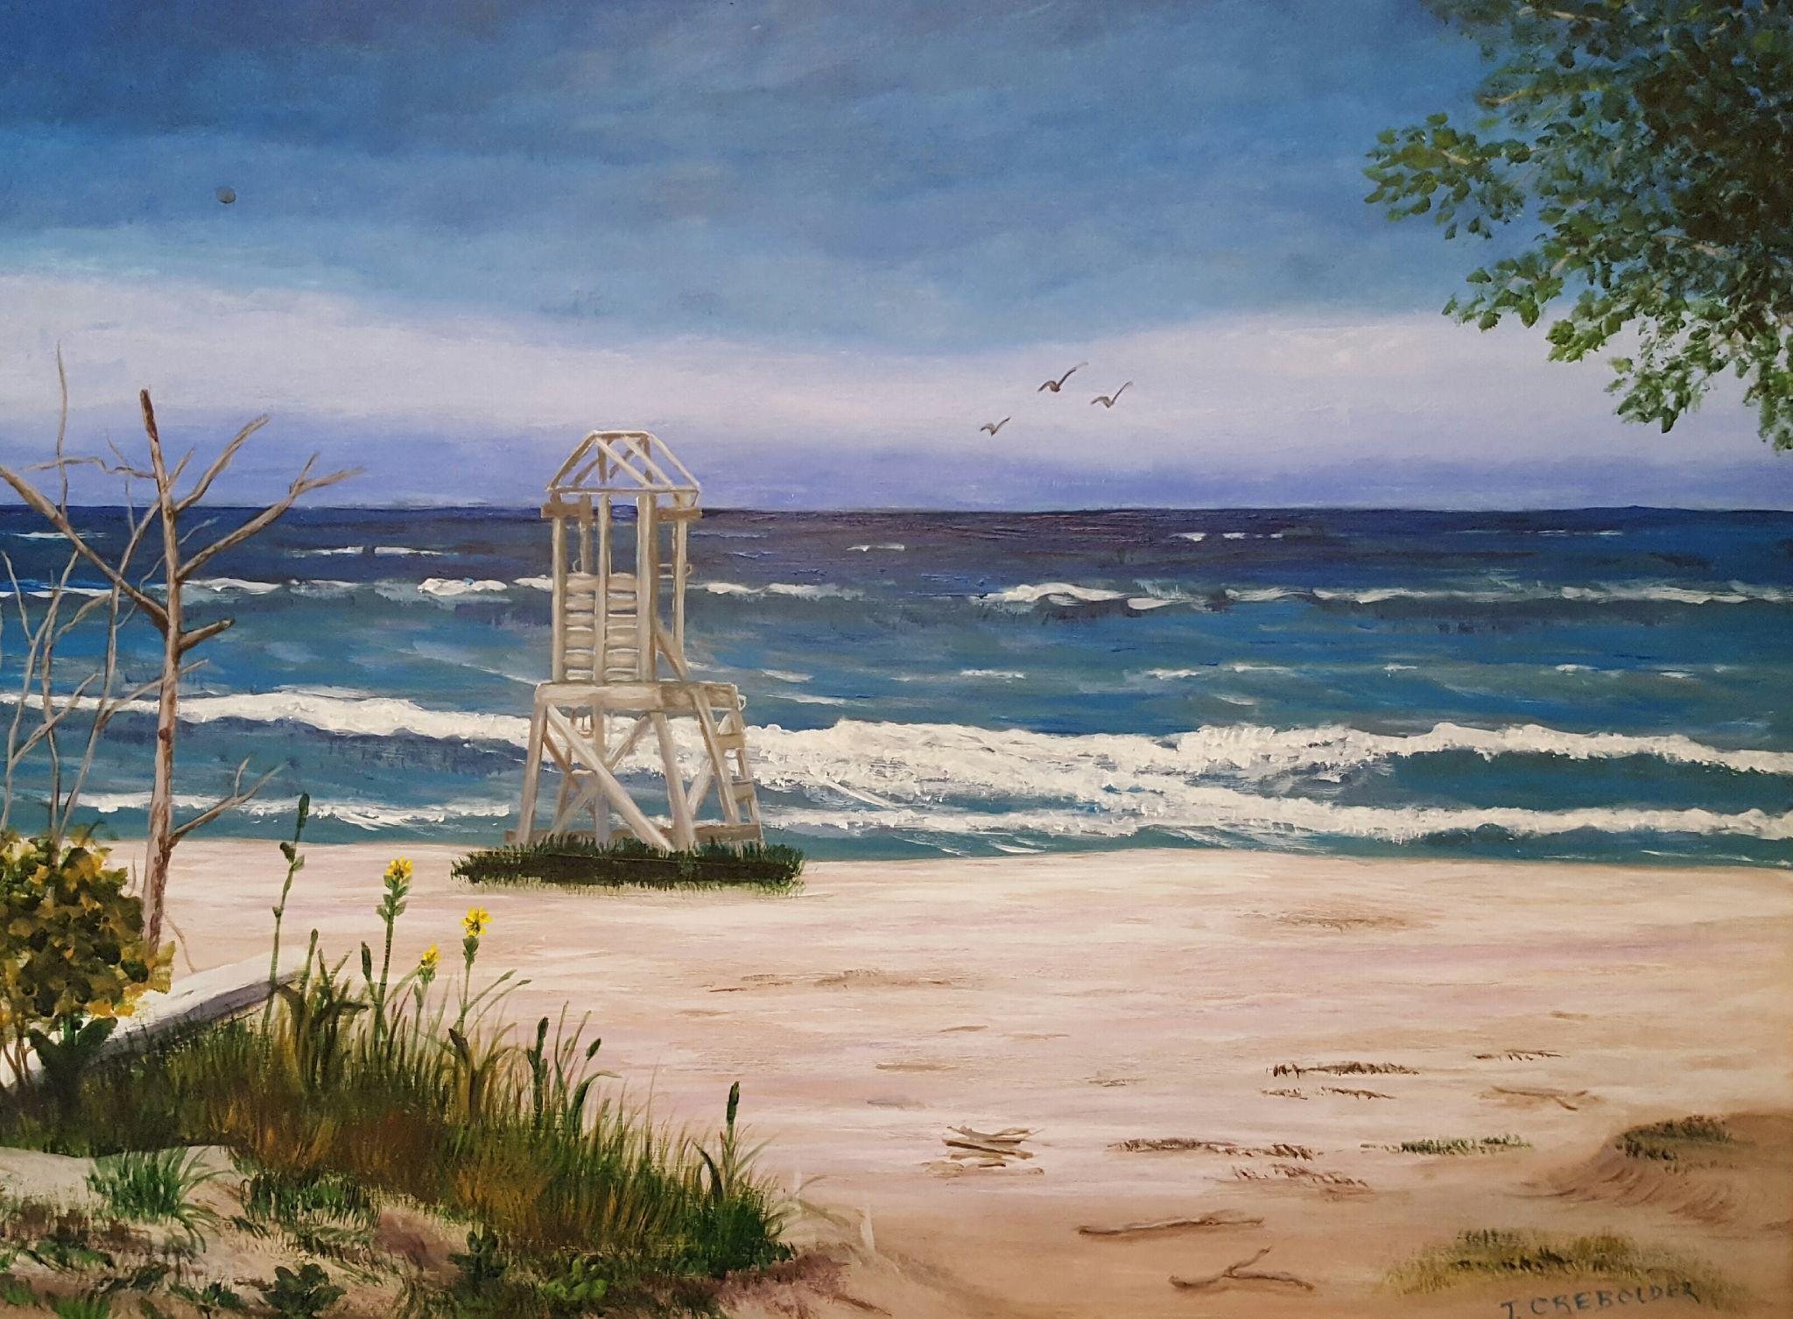

The MacKay Centre
10 Nelson St. E., Goderich
(corner of North and Nelson)

August 8th, 9th, 10th

Friday & Saturday 9am – 5pm
Sunday 10am – 4pm

Admission Free & Accessible Building

